A picture containing clipart

Description generated with very high confidence

Hands-on

Creating an app using Beanstalk

UNIX/Linux Training

[**support@intellipaat.com**](mailto:support@intellipaat.com)

**+91-7022374614**

**US: 1-800-216-8930(Toll Free)**

**Creating an app using Beanstalk**

**Step 1:** First click on **Get started** in the Elastic Beanstalk console

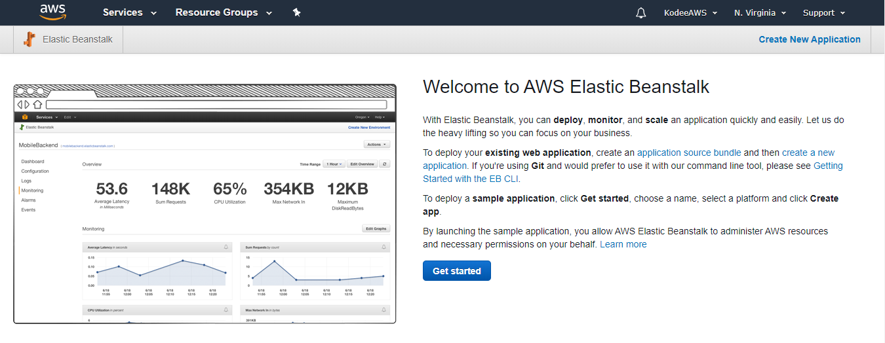

**Step 2:** Then give your application a name, choose the platform and go ahead click on **Create application**

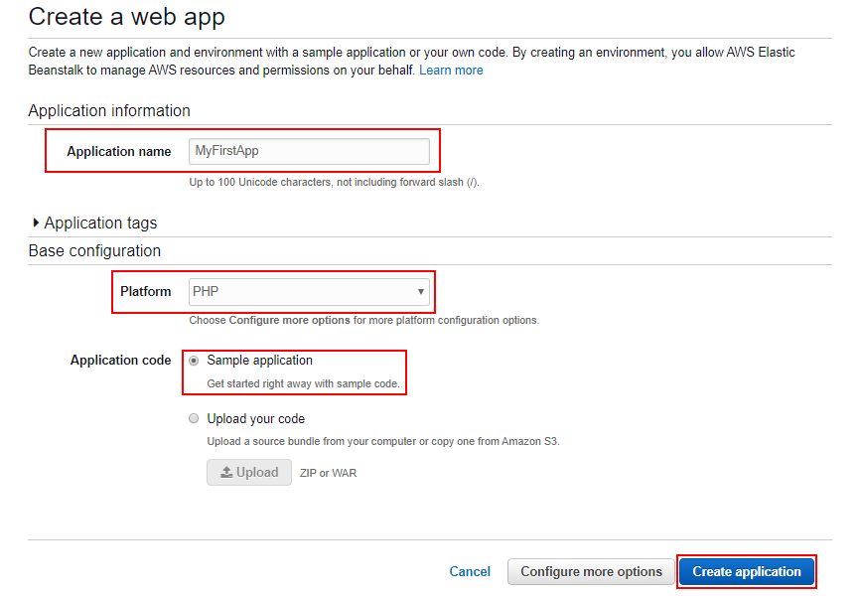

**Step 3:** Once the creation process is done, click on the URL to view the hosted sample website

